* Name: **Parth Bhandari**
* Picture: 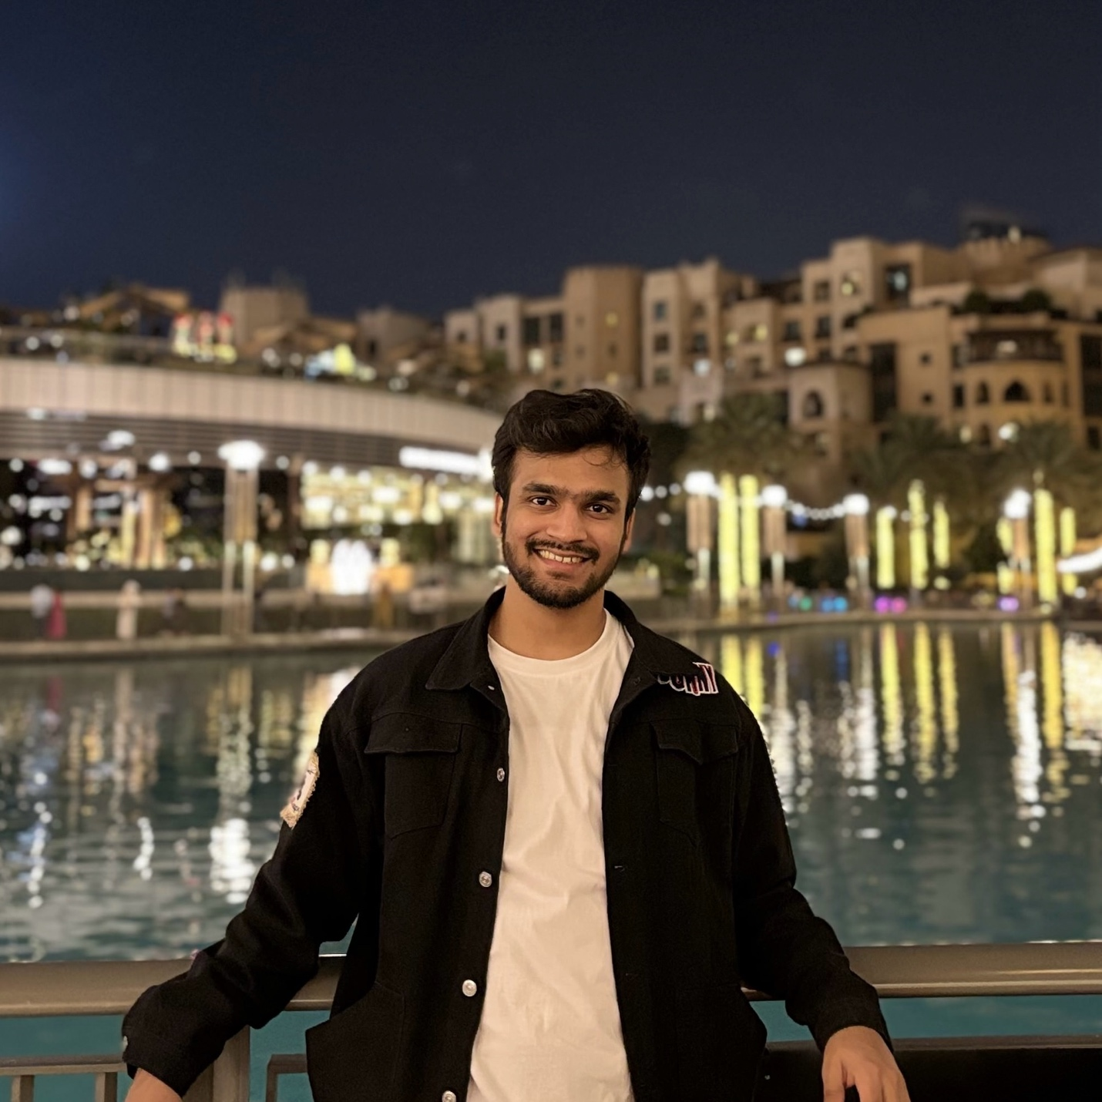
* Degree and Department: MS in Computer Science.
* About: I am a first-year M.S. student majoring in Computer Science, working under the supervision of Dr. Daniel Brown. My research interests include Generative AI, Large Language Models, and I have experience with recommendation systems and conversational chatbots.
* Links:
  + Personal Github Link: <https://github.com/parthbhandari1>
  + Linkedin: <https://www.linkedin.com/in/parthbhandari/>